IW-14
YEAR 9 SCIENCE
PHYSICAL SCIENCES
LIGHT TEST (MODIFIED)

NAME: CLASS: Mark: 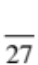

Achievement standards being tested
Energy transfer through different mediums can be explained using wave and particle models.

Mark | ND | NW | C | HC | O
Mark Range

Multiple Choice Write the answer to each question in the appropriate box at right.

1. The light energy we feel as heat is:

(a) infrared.
(b) ultraviolet.
(c) microwave.
(d) x-ray.

2. The part of the eye that an image forms on is the:
QUESTION | ANSWER
1
2
3
4
5
6
7
8

(a) iris.
(b) lens.
(c) retina.
(d) optic nerve.

3. Refraction of light is:

(a) the wave motion of light as it passes through a substance.
(b) the bending of light as it passes from one substance into another.
(c) a reflection of light rays at the surface of a medium.
(d) the failure of light to pass through a very dense substance.

4. Light travels in lines.

(a) diagonal
(b) curved
(c) horizontal
(d) straight

Questions 5 refers to the following diagrams.

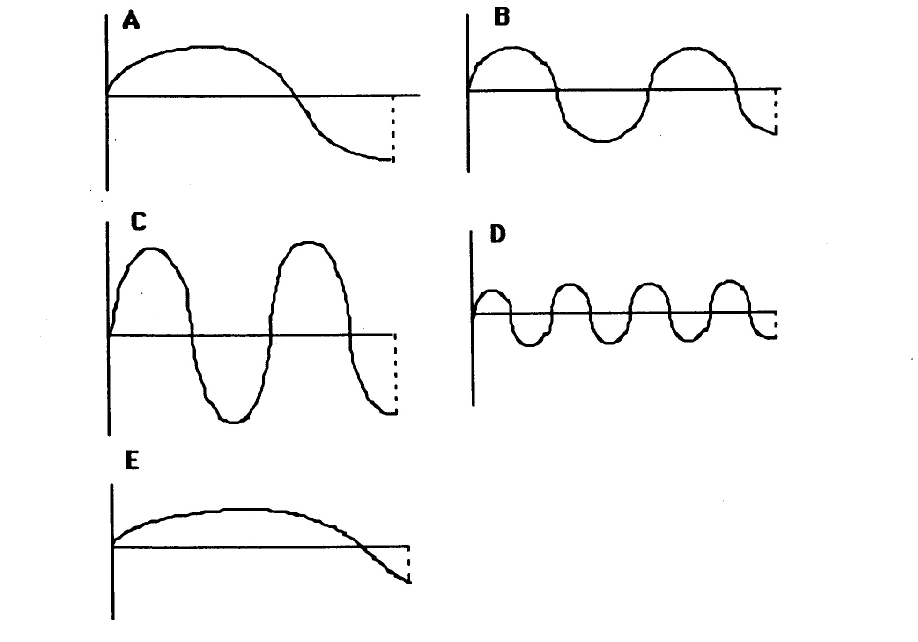

5. The wave with the greatest amplitude is:

(a) A
(b) B
(c) C
(d) D
(e) E

6. Mirrors will light rays.

(a) scatter
(b) refract
(c) transmit
(d) reflect

7. Which material can be classified as translucent, allowing some light through?

(a) A piece of cardboard.
(b) Window glass.
(c) Frosted glass.
(d) Carpet.

8. The speed of light in air is:

(a) 300 000 km/sec.
(b) 30 km/sec.
(c) 340 km/sec.
(d) 3000 km/sec.

Short Answer Write the answer to the questions in the spaces provided.

1. Light is a transverse wave. In which direction do the particles move?
(Circle the correct answer.)

Up and down. Backwards and forwards (left and right).
(1)

2. Draw the path of the rays in the following diagrams.

B

(5)

3. (a) Label the following diagram of a wave.

Choose from the following words.

frequency speed amplitude wavelength

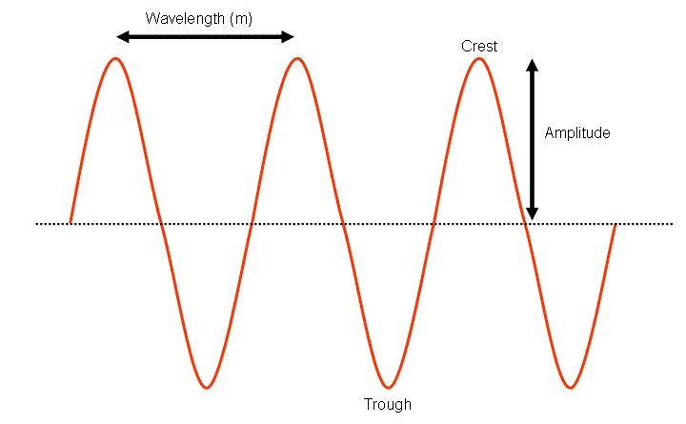
(2)

(b) Complete the diagram of the electromagnetic spectrum by naming the remaining bands.

Choose from the following words.

gamma ray microwave ultraviolet infrared

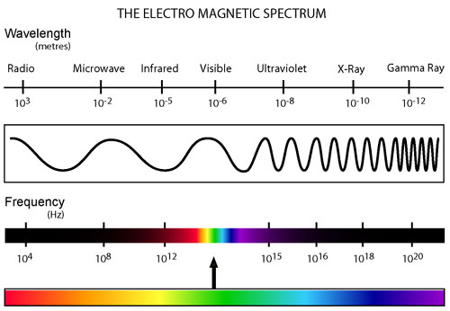
B
A

A: B:

C: D:

(4)

4. (a) Label the following illustration of the human eye. Choose from the following words.

iris optic nerve retina pupil lens cornea vitreous humour
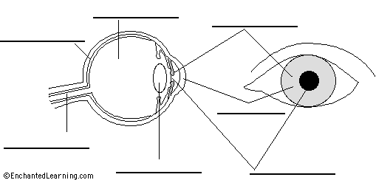
(7)

